Associe chaque personnage d’Halloween à sa définition
 |  |  | Can't play in the sun or eat garlic |  |  |  |  |  |  |  |  |  |  | Ghost
 |  |  | Can't see, speak or hear |  |  |  |  |  |  |  |  |  |  | Bat
 |  |  | Can fly through walls and disappear |  |  |  |  |  |  |  |  |  |  | Witch
 |  |  | Can sleep hanging upside down |  |  |  |  |  |  |  |  |  |  | Werewolf
 |  |  | Can turn into a wolf once a month |  |  |  |  |  |  |  |  |  |  | Mummy
 |  |  | Can cast spells and curses |  |  |  |  |  |  |  |  |  |  | Vamire
 |  |  | Can be carved into faces |  |  |  |  |  |  |  |  |  |  | Zombie
 |  |  | Can't eat real food (only brains) |  |  |  |  |  |  |  |  |  |  | Pumpkin
Complète les phrases (rappel WHOSE =A qui ?)
1 | Whose __shirt__ is this? |  |  |  |  |  |  |  |  | It's the zombie's
2 | Whose _________________ is this?
3 | Whose coffin _________________?
4 | ______________ bandage is this?
Ecris un petit poème en te servant de la première lettre pour commencer ta phrase
 |  | Vampire |  |  |  | Example | B | Bats are scary.
 |  | Werewolf |  |  |  |  | A | A witch can fly.
 |  | Mummy |  |  |  |  | T | The ghost can disappear.
 |  | Zombie
 |  | 1. Vas à la ligne pour chaque lettre
 |  | 2. Fais une phrase en anglais commencant par chaque lettre
……………………………………………………………………………………………………………………………………………………………………………………………………………………………………………………………………………………………………………………………………………………………………………………………………………………………………………………………………………………………………………………………………………………………………………………………………………………………………………………
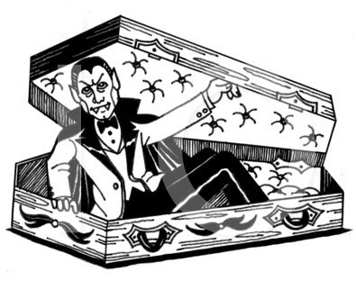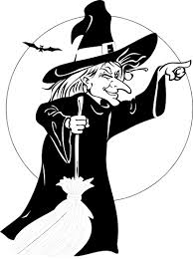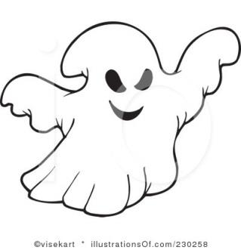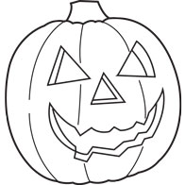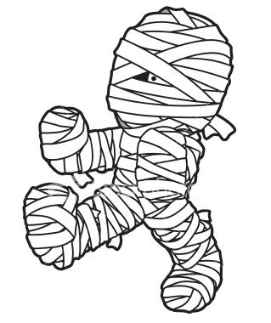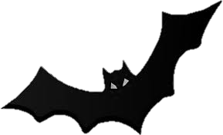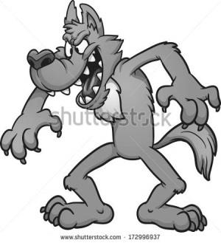
Remets les lettres dans le bon ordre pour composer le nom des personnages.
Gshto …………………………… veprmia ……………………….. ppmnuki………………………….
Bta …………………………………. Icnffo …………………………….. derpis ……………………………………
Cdsrae…………………………. Yoopks ………………………….. weehanllo ………………………

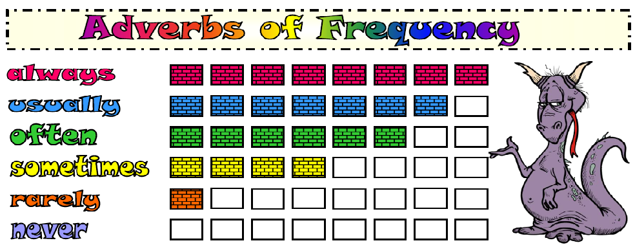
Recopies les phrases en y ajoutant l’adverbe de fréquence (rappel : l’adverbe de fréquence se place AVANT le verbe). Soulignes les verbes en rouge et écris les adverbes en vert.

1.Mr.Jones gets up at 6:30. (always)
............................................................................................................................................
2. She plays the flute. (sometimes)
............................................................................................................................................
3. I walk my dog in the park. (often)
..............................................................................................................................................
4. He reads an English story book. (rarely)
..............................................................................................................................................
5. Steve doesn't play computer games. (never)
...............................................................................................................................................
6. Claire goes to bed early. (always)
...............................................................................................................................................
7. Our dog doesn't eat spinach. (never)
...............................................................................................................................................
8. Mike swims in their swimming pool. (often)
……………………………………………………………………………………………………………………………………………
9. I eat my lunch in the cafeteria. (sometimes)
................................................................................................................................................
10. She walks to school. (usually)
................................................. …………………………………………………………………………………………..

Remets les mots dans le bon ordre. Pense à la place de l’adverbe de fréquence dans la phrase !

1. never / food / Julia / eats / fast
....................................................................................................................................................
2. play / they / sometimes / volleyball
...................................................................................................................................................
3. cat / milk / her / drinks / always
....................................................................................................................................................
4. walks / often / dad / work / my / to
....................................................................................................................................................
5. usually / makes / mum / a / cake / my
....................................................................................................................................................
6. social / I / study / rarely / sciences
....................................................................................................................................................
7. cheat / we / exams / never / the / in
………………………………………………………………………………………………………………………………………………………………

