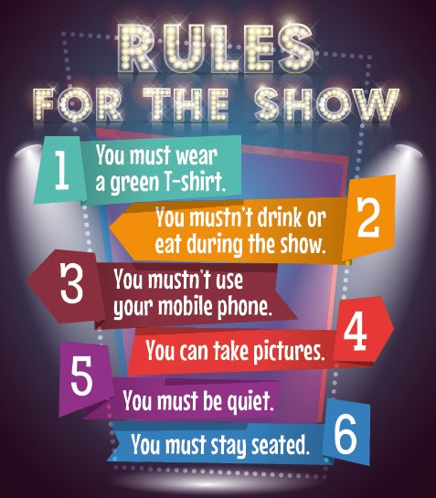 | - Read the poster carefully.  - Match each rule to the corresponding sign:
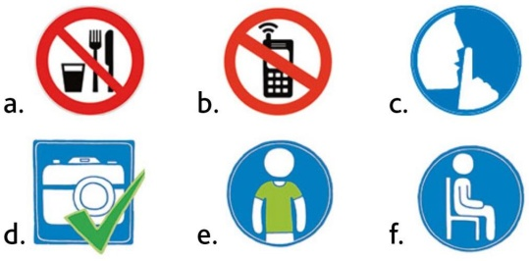

Rule 1 = Sign ......... Rule 4 = Sign .........
Rule 2 = Sign ......... Rule 5 = Sign .........
Rule 3 = Sign ......... Rule 6 = Sign .........

- Think:

What is the word expressing a permission? ……………………. + Base form of the verb
What is the word expressing an obligation? ……………………. (ex: ………………..)
What is the word expressing an interdiction? ……………………

- Write the rules corresponding to these signs:

. 
Sign 1…………………………………………………Sign 2…………………………………………………………………..

Sign 3…………………………………………………Sign 4…………………………………………………………………..

5. Complete the following sentences with the correct words.

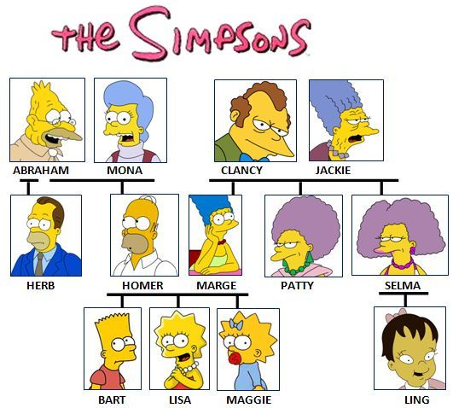
cousin husband grandmother wife aunt nephew son Homer Marge Homer’s Marge’s brother sister Abraham grandfather mother Herb grandparents niece

1. Bart is Homer’s and Marge’s _____ 2._________and __________ are Bart’s parents.
3. Lisa is __________ and _________ daughter. 4. Herb is Homer’s ____________.
5. Patty is Selma’s __________ 6. __________ is Homer’s father. 7. Abraham is Bart’s __________.
8. Jackie is Marge’s __________9. _________ is Maggie’s uncle. 10. Selma is Lisa’s __________.
11. Marge is Homer’s _____ 12. Homer is Marge’s _______13. Abraham and Mona are Bart’s_______.
14. Ling is Lisa’s __________15. Maggie is Patty’s __________ .
16. Bart is Selma’s __________.17. Jackie is Maggie’s __________.

N’oublies pas qu’on utilise le ’S pour la marque de possession / le lien de parenté (= le génitif)

1. Choissisez (surlignez) entre there is / there are (=forme affirmative)

1. There is / There are children in the school. 2. There is / There are an orange in this basket. . 3.There is / There are a dog in the house. 4. There is / There are seven bananas in the fridge . 5.There is / There are a cat under the table. 6.There is / There are no picture on the wall. 7.There is / There are many cars in the street. 8.There is / There are books on the table. 9.There is / There are five birds. 10.There is / There are a beautiful girl in our class. 11.There is / There are no cookies left on the table. 12.There is / There are a lot of noise 13.There is / There are no computer on your desk. 14.There is / There are a pencil on the floor. 15.There is / There are no eggs left.
2. Choisissez (surlignez) entre is there ? / are there? (= forme interrogative)
1. Is there / Are there a lot of noise at night? 2. Is there / Are there many boys in your school? 3. Is there / Are there a post office near the bank? 4. Is there / Are there any oranges in the basket? 5.Is there / Are there elephants in the zoo?
3. Choisissez (surlignez) entre there isn’t ou there aren’t (=forme négative)
1. There isn’t / there aren’t many people in the streets. 2. There isn’t / there aren’t any butter in the fridge. 3. There isn’t / there aren’t any plates on the table. 4. There isn’t / there aren’t any beer in the bottle. 5. There isn’t / there aren’t any tea in the cup.
4 .Faites des phrases ou des questions avec is there/there is ou are there/there are:
1. __________ no butter in the fridge. 2. __________ many rooms in her house? 3. __________ a lot of snow in the mountains. 4. __________ any mistakes in this text? 5. __________ one question left. 6. __________ no insects in my garden. 7. __________ nobody in. 8. _________ nothing to do? 9. __________ a lot of food in the kitchen. 10. __________ many birds in this forest?
5. Fais des phrases pour dire ce qu’il y a ou non dans ta chambre ou dans ta maison
___________________________________________________________________________________________________________________________
Rappel : On utilise there is / there are pour dire « il y a », à la forme négative on rajoute –not au verbe et pour poser la question on inverse !
SUPER POWERS FOR SUPERHEROES

Ecris le vocabulaire approprié pour chaque super héros puis à l’oral fais des phrases pour dire ce que chacun peut faire (utilise CAN ). Pour aller plus loin : entraines toi à les décrire (physique, personnalité etc…à l’oral)

shoot lasers – fly- breathe under water - climb walls - do martial arts - run fast






  

