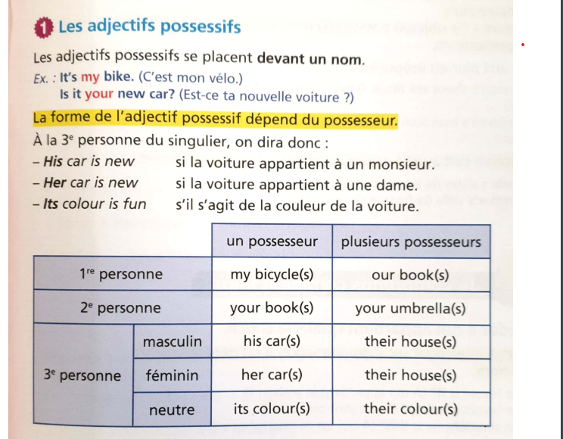
ACTIVITY 1 Complète les phrases suivantes par he’s ou his.
- This boy is John……………….English but …………….father is American.
- That man is a doctor. ……………………fifty-six.
- Mr. Eliott is American. ………………car is very big.
- Is Alex an English boy ? No, …………………..a French boy.
ACTIVITY 2 Complète par l’adjectif possessif qui convient.
- Is that your tablet ? Yes, it’s ………………….tablet.
- This boy is Irish. …………………………name is Mathew.
- Sarah is French but ……………………mother is Algerian.
- Is this ………………book ? Yes, it’s my book.
ACTVITY 3 Réécris les phrases suivantes en remplaçant les expressions en gras par l’adjectif possessif correspondant.
- It’s John’s car. …………………………………………………………………………………………………………
- It’s Jessica’s racket. ………………………………………………………………………………………………..
- My parents are furious. My parent’s car is damaged. ……………………………………………..
- Is your sister’s jacket new ? …………………………………………………………………………….........
EXPRIMER LA POSSESSION AVEC HAVE GOT
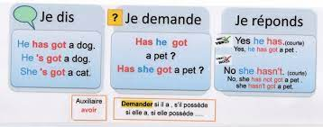

ACTIVITY 1 Complète les phrases suivantes en conjuguant have got.
a. I …………………………………… a bike.
b. My father …………………………………….. a computer.
c. My parents ………………………. a new car.
d. We ……………………………………. a dog.
e. My uncle ……………………………. a boat.
ACTIVITY 2 Mets chacune des phrases suivantes à la forme interrogative , puis négative.
- The Jones have got two children.
……………………………………………………………………………………………………………………………………………………………………………………………………………………………………………………………………………………………………………..
- They’ve got a big car.
……………………………………………………………………………………………………………………………………………………………………………………………………………………………………………………………………………………………………………..
- Helen has got a large dining room.
……………………………………………………………………………………………………………………………………………………………………………………………………………………………………………………………………………………………………………..
- She’s got two fridges.
………………………………………………………………………………………………………………………………………………………………………………………………………………………………………………………………………………………………………………
- My cousin’s cat has got green eyes.
………………………………………………………………………………………………………………………………………………………………………………………………………………………………………………………………………………………………………………
ACTIVITY 3 Réécris les phrases suivantes en utilisant la forme contractée chaque fois que c’est possible.
- I have got a car and my brother has got one too.
……………………………………………………………………………………………………………………………………………….
- We have got three bottles of juice in the fridge.
……………………………………………………………………………………………………………………………………………….
- We have not got a bottle of milk.
………………………………………………………………………………………………………………………………………………..
- Have you got a computer ?
………………………………………………………………………………………………………………………………………………..

- ……………………………………….. 2. ………………………………… 3. ………………………..............
4. ………………………………………….. 5. …………………………………………. 6. ………………………
ACTIVITY 4 Dis ce que tu as et ce que tu n’as pas dans ta chambre, utilise les mots de liaison « and », « but » et « too ». …………………………………………………………………………………………………………………………….

