Collège Edmée Varin d’Auteuil \ 5ème \ Anglais \ Laura’s diary du 2 au 5 novembre 2021 p. ½
Compréhension Ecrite
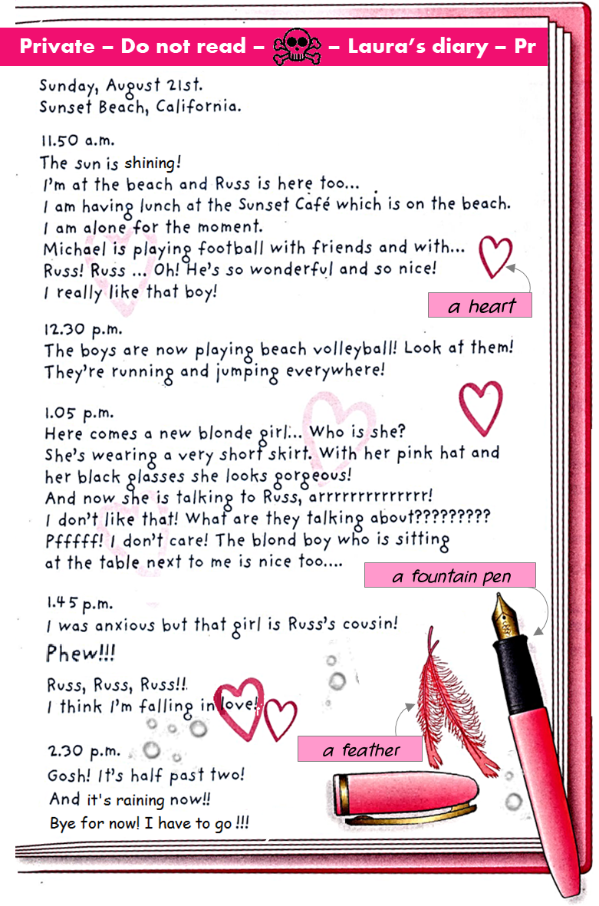
Commence par prendre connaissance des questions sur la page suivante

Collège Edmée Varin d’Auteuil \ 5ème \ Anglais \ Laura’s diary du 2 au 5 novembre 2021 p. 2/2
- Repère les éléments qui accompagnent le texte, puis réponds sans faire de phrase
- The author of this document is … ____________________________________________________________
- What sort of document is this?
a letter to a friend a newspaper article the page of a diary
Justify your answers (with 3 elements)
____________________ _____________________ ____________________
- Date of publication? _____________________________________
- Place of publication? _____________________________________
- Lis attentivement les questions, puis lis le texte pour y répondre (avec des phrases complètes)
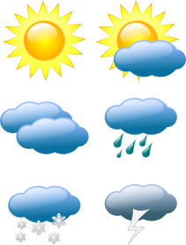
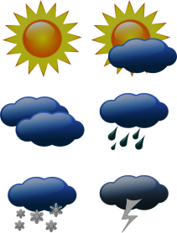
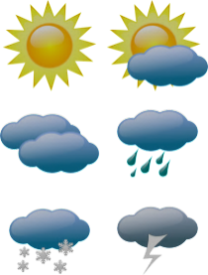
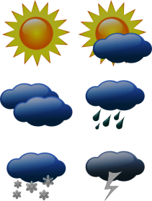
At 11.50 a.m.
- What is the weather like?
Justify your answer ________________________________________________________________________
- Where is the author? ______________________________________________________________________
- What is she doing? ________________________________________________________________________
________________________________________________________________________________________
- What are the boys doing? ___________________________________________________________________
- Describe Russ with two adjectives
____________________________ _______________________________

At 1.05 p.m.
- What is the girl wearing? ___________________________________________________________________
________________________________________________________________________________________
- Does the author like the new girl?
- … and, what about the boy sitting at the table next to hers?
At 1.45 p.m.
- What is happening to the author? ____________________________________________________________
- Who is the new girl? _______________________________________________________________________
At 2.30 p.m.
- Is the sun shining? _________________________________________________________________________

