Welcome to the Australian International Section at DSM
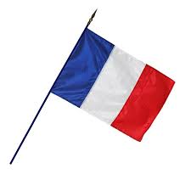
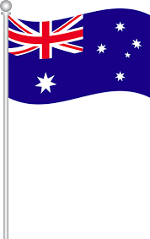
The Australian International Section of Dumbea-sur Mer opened in February 2017 with a group of 19 pupils in 6ème from different nationalities: Australian, French, Scottish, Irish and mostly Oceanian.
In 2018, the Australian International Section will be made up of 26 pupils in 5ème and 28 in 6ème, all keen on learning about Australia and its language and cultutre.
Pupils in this section are taught the Australian literature and civilization with an Australian teacher and they also learn Australia’s history and geography with a history-geography teacher having a certification to teach in English. Mathematics are also taught in English. That is why their timetable is so busy with 5.5 hours more than the normal classes, more homework and they also need some time to make their projects.
A school exchange is organized every two year with our school sister, Glen Eira College, situated in Melbourne, a multicultural Australian city. This project will culminate with a trip in September 2018 which will enable the pupils in 5ème to be in immersion at GEC (Glen Eira College) and practise their English intensively. They will also have the opportunity to stay and share moments with Australian host families.
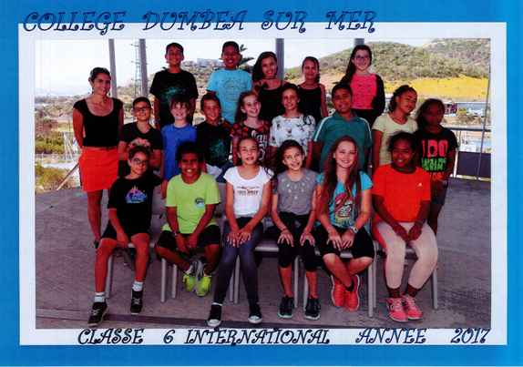
Teachers teaching in this Australian International Section:
-Mrs Tegualda AVILES (History/geography)
-Mrs Jessica BLANC (English)
-Mrs Verity EPETAHUI (Australian Literature and culture)
-Mr Didier PRUILH (Mathematics)

