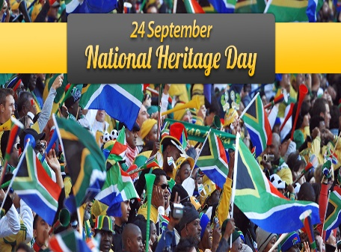
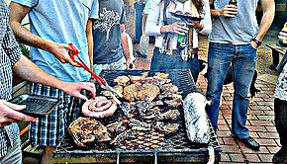
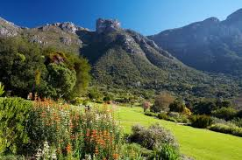
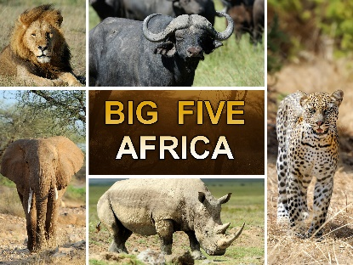
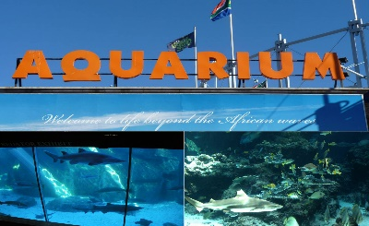
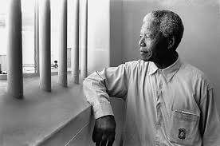
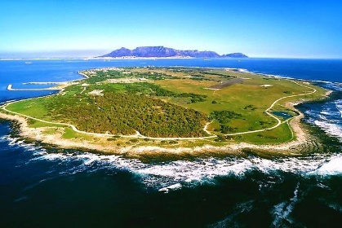
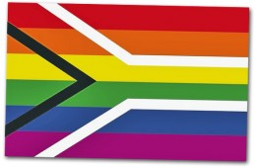
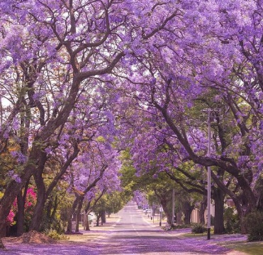
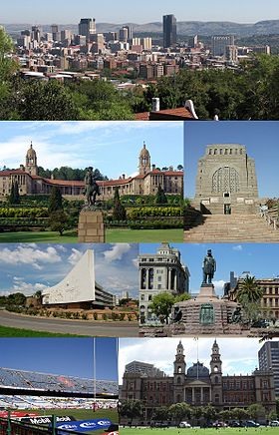
Braai it’s South African Barbecue
Two Oceans Aquarium
Kirstenbosch garden
Come visit Cape Town City
Cape Town City is located in the South-East of the South Africa. You can visit Two Oceans Aquarium and the Kirstenbosch garden.
Come enjoy a safari
Kruger National Park is a very popular park because you can see wild animals, like a lion, leopard, rhino, buffalo, and elephant
Nelson Mandela
Robben Island
Come in Robben Island
Robben Island is where Nelson Mandela was imprisoned. This old jail became a museum.
Come and spend a day in Pretoria
Pretoria is a capital of South Africa. Her nickname is « city of Jacaranguas ». There are many beautiful trees.
WELCOME TO THE RAINBOW NATION

Enora et Ludovic
Pretoria city
Jacaranguas in Pretoria
Come play during Heritage Day
Heritage Day is a cultural fair in South Africa. It’s celebrate on September 24th. People dance, sing, wear traditional outfits, eat braai…

