STOP CYBERBULLYING
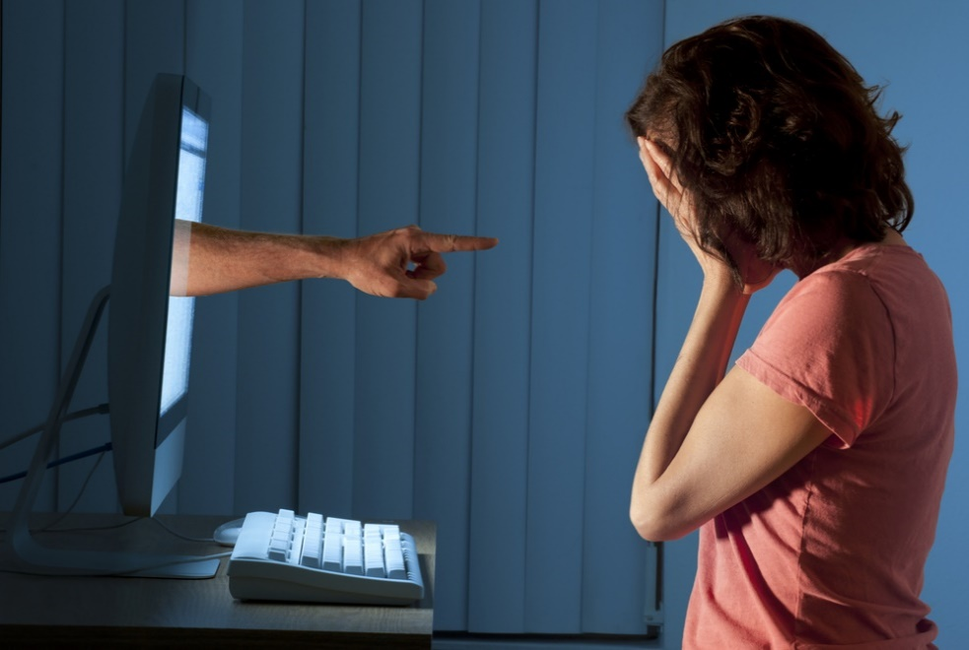

ADVANTAGES DANGERS
-SPEAK WITH FAMILY AND FRIENDS -MEET BAD PEOPLE
-WATCH FUNNY VIDEOS -BE A VICTIM OF CYBERBULLIYNG
-POST THE PHOTOS -CAN BE HACKED
- DOWNLOAD MUSIC -RECEIVE THREATENING MESSAGES
ADVICES
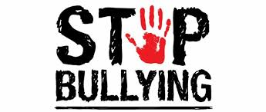
-DON’T POST PERSONNAL INFORMATION
-THINK BEFORE POSTING A MESSAGE
-CHECK YOUR PRIVACY SETTING
-DO NOT ACCEPT BAD TREATMENT FROM SOMEONE

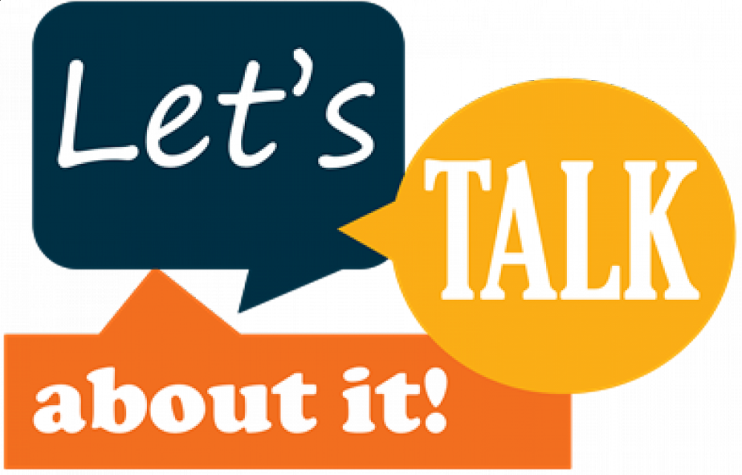

Damaris and Noemie 301

