POLUTELE TAOFIFENUA
THE SUPERWOMAN
  1 | 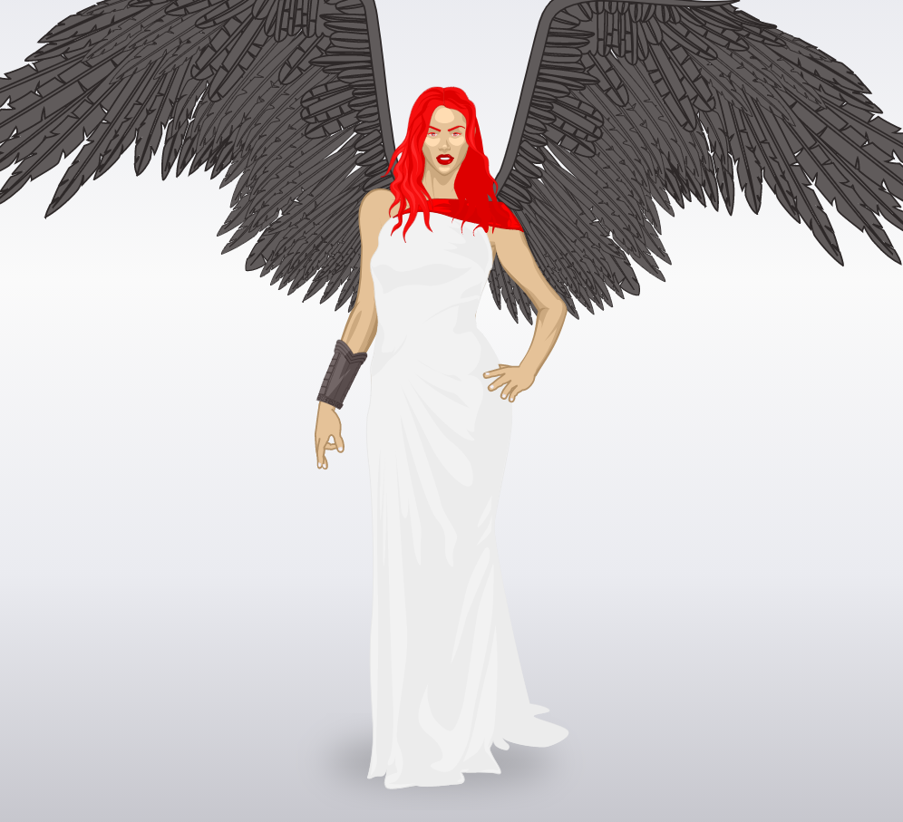  2
Her name is Andy, It’s a superwoman since the age of twelve, She became a superhero because her parents were kidnapped by her father's enemy . She met her uncle who is a superhero to her and helped her to become one to save her parents and fight the bad guys
She can fly,She has the ability to climb glass wall or the tall buildings
She is able to make people or objects in stones in a single glance with his eyes red. In the first picture you can see Andy in everyday life and in the second you can see that she can transform with the bracelet.
She has big wings so she can fly on top of the tall buildings.

