Exercice n°1 :

Recopie, puis complète les phrases suivantes avec « there is » ou « there are »

a) In my bedroom, ………………. a purple rug.

b) On my desk, ……………… books.

c) …………………… a brown wardrobe.

d) On my bed, …………………….. two pink pillows.

e) Under my bed…………………..toys.

f) …………………….. a beautiful chair.

NB : pour réussir cet exercice regarde bien le nom qui suit,
S’il se termine par un « s » il est au pluriel, il faudra donc écrire « there are ». S’il est au singulier, tu devras écrire « there is »

Puis écris trois phrases pour décrire ce qu’il y a dans ton cartable :

……………………………………………………………………..

………………………………………………………………………

……………………………………………………………………..

………………………………………………………………………

……………………………………………………………………….
Exercice n°2 :
Décris la chambre d’Alex (manuel page 51, photo en haut de la page).
Il te faudra faire au moins 3 phrases au singulier (there is) et 3 autres au pluriel (there are) essaie d’utiliser un maximum de mots de vocabulaire vus dans les annexes.

1…………………………………………………………………

2…………………………………………………………………

3…………………………………………………………………

4…………………………………………………………………

5…………………………………………………………………

6…………………………………………………………………

Exercice n°3
WHAT IS IT ?

Circle the good answer. Entoure la bonne réponse

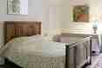
a) a kitchen

b) a bedroom

c) a bathroom

d) a living room

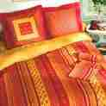
a) a bed

b) a chair

c) a table

d) a lamp

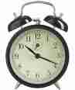
a) a toy

b) a book

c) an alarm clock

d) a video game

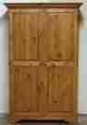
a) a computer

b) a telvision

c) a chest of drawers

d) a wardrobe

a) a bed
b) a blanket

c) a pillow

d) a rug
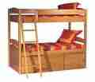
a) a chair

b) a toy

c) a wardrobe

d) bunk beds
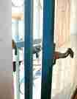
a) a bed

b) a closet

c) a door

d) a window

Exercices n°4

Remets les lettres dans l’ordre pour former un mot désignant un meuble.

1. I sleep in a big……………………… (D E B)

2. Take a …………………….. ( R I H A C) and sit down

3. Her …………………………….. ( E R R W D A B O) is full of clothes.

4. I have a lot of books on my ……………………. (D S K E).

5. I look at myself in the …...………………….( R R O I M R).

6. I see a blue …………………………….. (D I B S E E D) table.

7. My …………………………...( P L M A) is big.

8. I have a nice ………………………… ( T O C S L E).

9. Can you draw the ………………………… (R T N A U C I S)

10. There is a …………………….. (G R U) next to my bed.

Exercice n°5

Complète les phrases suivantes avec la bonne préposition de lieu (on, under, in, above, next to, in front of, behind, bellow, between) voir annexe 3

1. The books are (sur) …………………………...the table.

2. Toys are (sous) ……………………...the bed.

3. There is a pen (dans)…………………...the bedside table

4. There is a tee shirt (derrière) ………………..the chair.

5. There is a mirror (en face de) …………………...the closet.

6. There are posters (au dessus de) ………………….the bed.

7. There is a pencil case (sur) …………………….the desk.

Exercice n°6 Compréhension écrite
1.Read the text. Lis le texte.
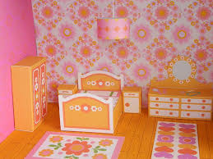
2.Highlight all the words you know. Surligne tous les mots que tu connais .

My bedroom is blue and yellow. There is a big double bed with a

green blanket. In front of this bed, there is a beautiful mirror.

On the desk, there are a lot of books. There is a small rug next to my bed.

Betwwen my bed and my closet, there are toys.

On the walls there are lot of posters.I also have purple curtains.
I love my bedroom !

Ecris en quelques phrases ce que tu as compris de ce texte.

………………………………………………………………………

……………………………………………………………….……

……………………………………………………………………

……………………………………………………………………

……………………………………………………………………

……………………………………………………………………

Exercice n°7
Describe those two bedrooms. Décris ces chambres.

……………………………………………………………………………….

…………………………………………………………………………….

……………………………………………………………………………….

……………………………………………………………………………….

……………………………………………………………………………….

Exercice n°7 (suite)

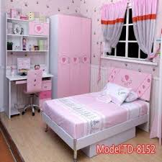

………………………………………………………………….

……………………………………………………………………

……………………………………………………………………

……………………………………………………………………

…………………………………………………………………..

…………………………………………………………………..

Exercice n°8
Complete with the following words.
Complète avec les mots suivants.
BATHROOM BEDROOM KITCHEN LIVING ROOM

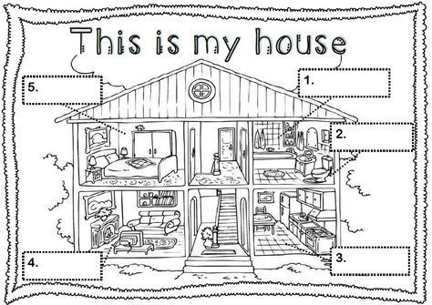

Exercice n°9 :

